MACH4METAL

metalworking machinery
Transito 21
6909 DA BABBERICH Netherlands
Tel. +31 (0)316-247123
Fax: +31 (0)316-247956

Bank No : 66.52.13.883
IBAN : NL33 INGB 0665 2138 83
BIC : INGBNL2A

DARLEY Pressbrake 3100 x 100 T
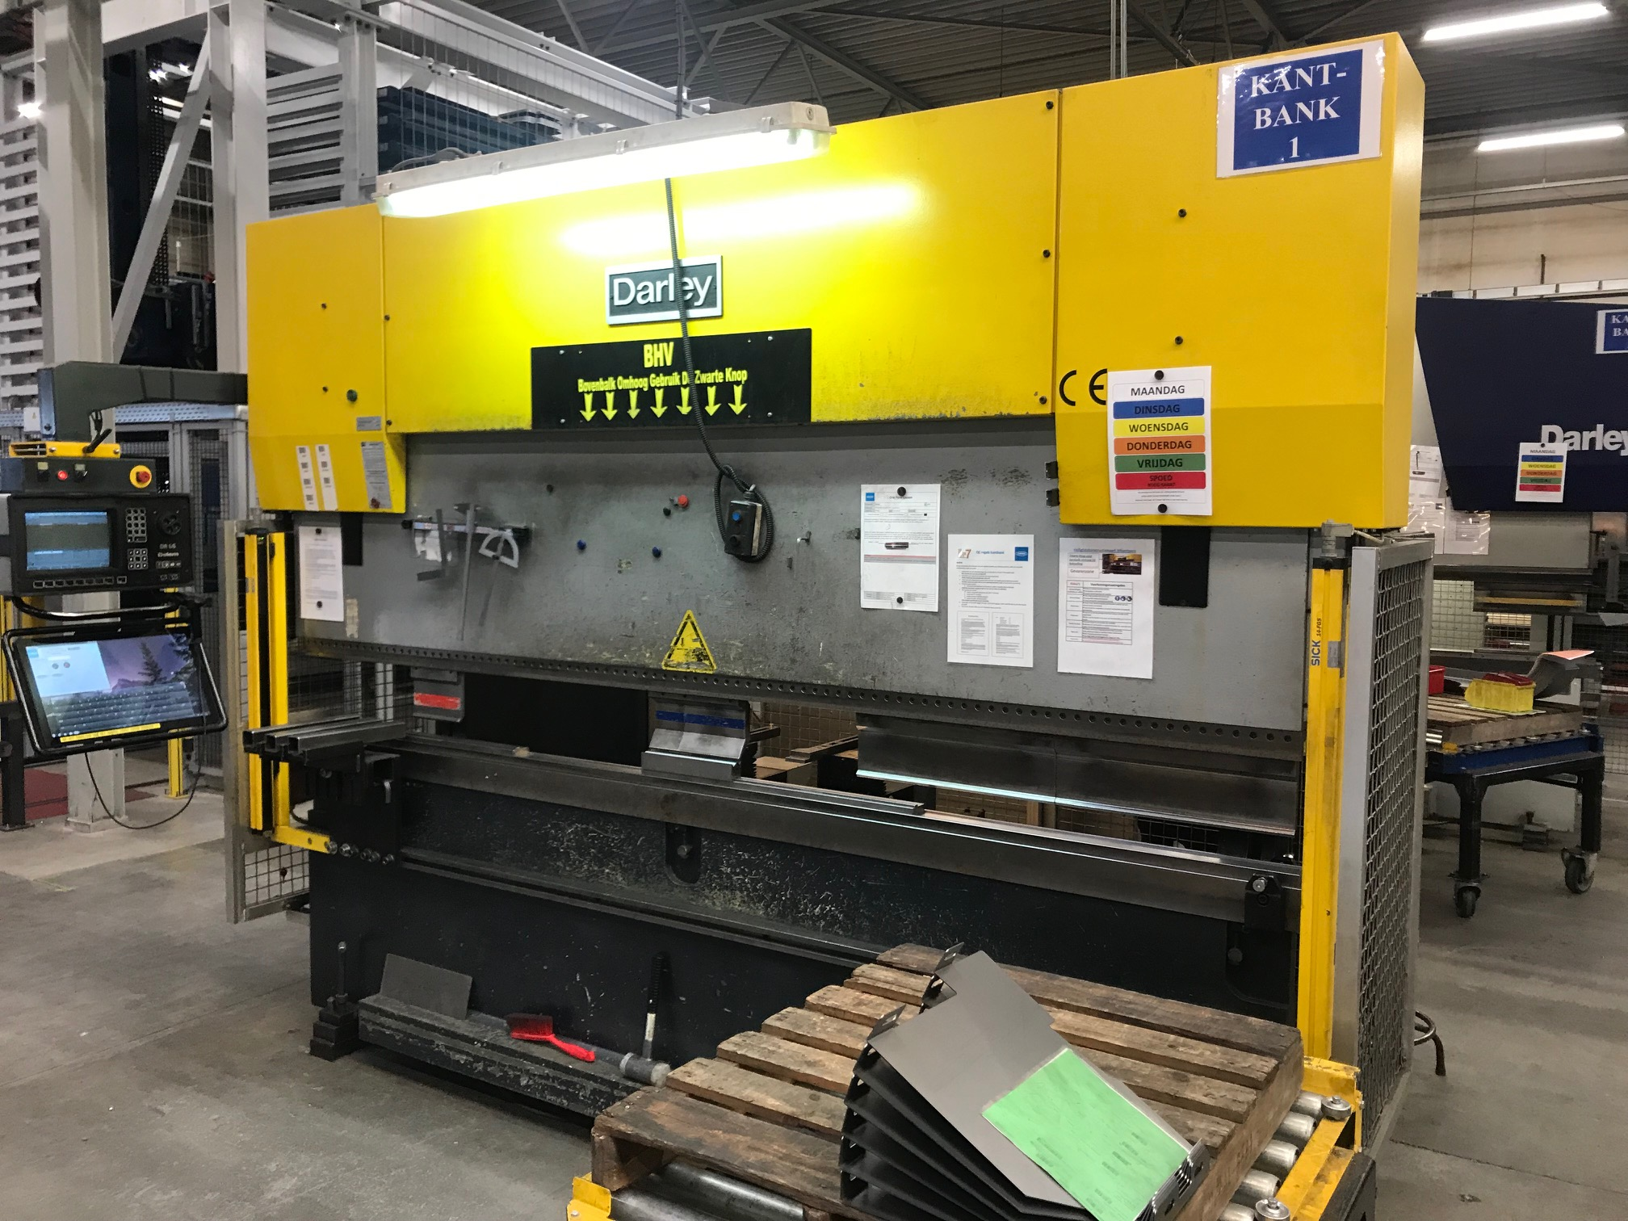
- Merk : Darley Holland
- Type : EHP-L 110
- Mach. No : 122 067
- YOP : 2000

- Max. bending length : 3.100
- Between column : 2.500
- Max. force : 110

- Troth : 250
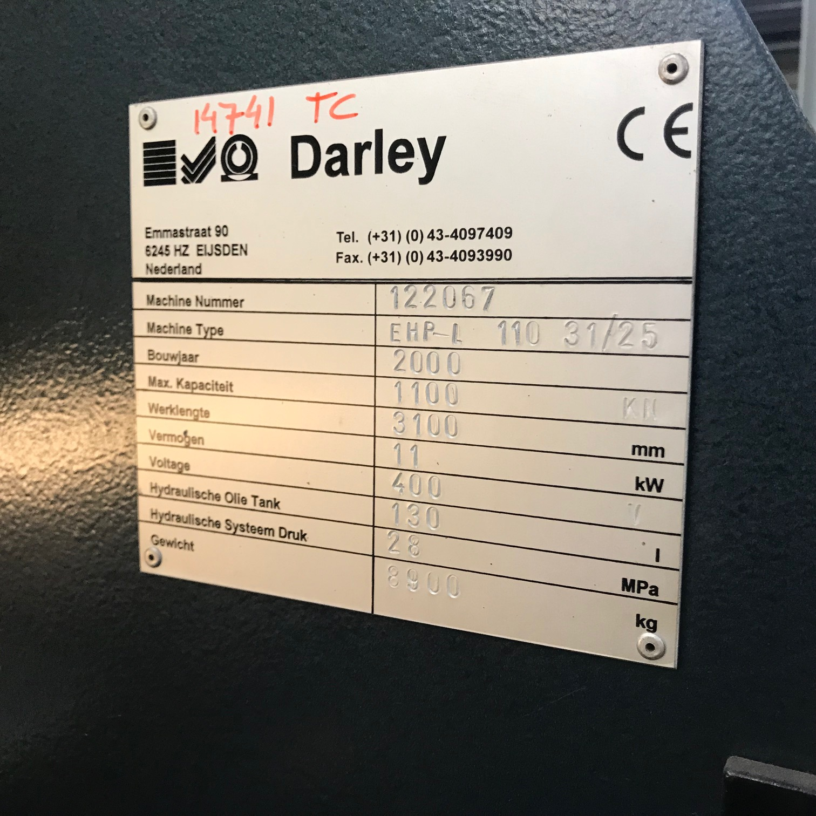
- Max. stroke : 150
- Die height : 375

- Approach speed : 100 mm/sec.
- Pressing speed : 10 mm/sec.
- Return speed : 65 mm/sec.

- CNC Control Delem DA 56
- Controlled axis
- Y1 / Y2 / X / V
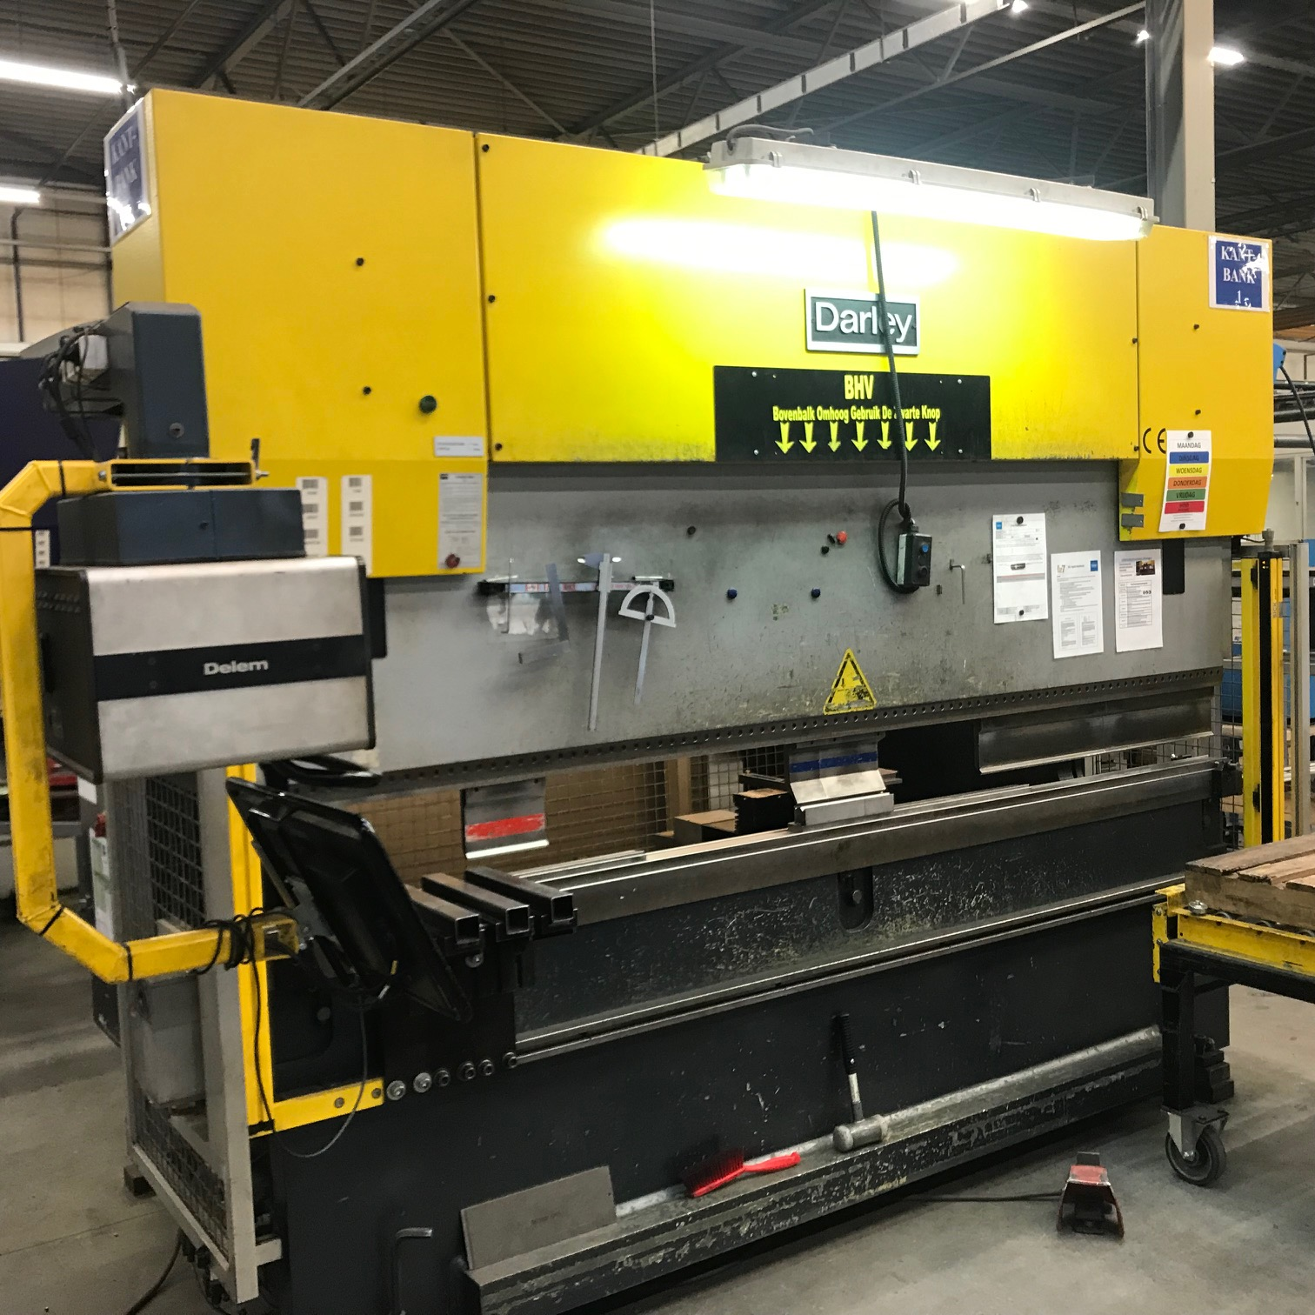
- Power : 400 V / 7.5 kW

- Length : 3.300
- Width : 2.000
- Height : 2.440
- Weight : 8.900
- Power : 11 kW

Please Note: The above information has been obtained to the best of our ability and belief from, and from the manufacturers where possible. It is given in good faith, but its accuracy can not be guaranteed. Accordingly, it will not form a representation or constitute contractual terms. We advise you to check any vital details!

